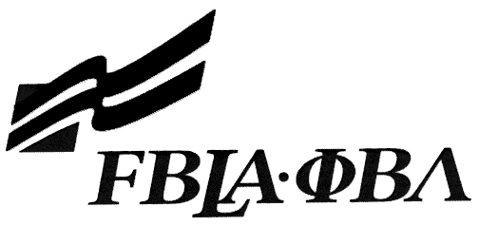

2017 FBLA SLC IMPROMPTU SPEAKING
Preliminary Round Topic

People often tell white lies (small lies) to spare another person's feelings. Is this a good idea, or is honesty always the best policy?



2017 FBLA SLC IMPROMPTU SPEAKING
Final Round Topic

Your younger sister or brother is contemplating joining FBLA. What advice would you give to convince her/him to join FBLA?

